Linear Smoothing Filter (Averaging Filter)

Before:



After:



Comments:

This filter blurs the image and makes the image appear “softer”.

Gaussian Filter:

Before:



After:



Comments:

This filter also blurs the image. It looks very similar to the averaging filter.

Median Filter:

Before:



After:



Comments:

This filter does make the image a little bit “softer”, but the image looks a bit “lighter” than the original image.

Laplacian Filter:

Before:



After:



Comments:

This filter shows the edges of the image. I did not scale the image since I can see the edges pretty clearly. However, you would need to scale the image if the edges are hard to see. If the edges are less pronounced, then a scaling might be necessary.

Sobel Filter:

Before:



X direction:

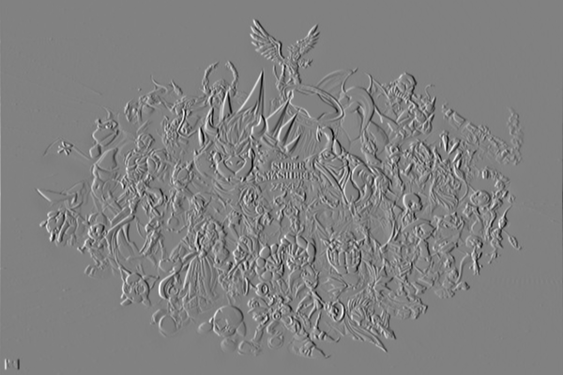

Y direction:

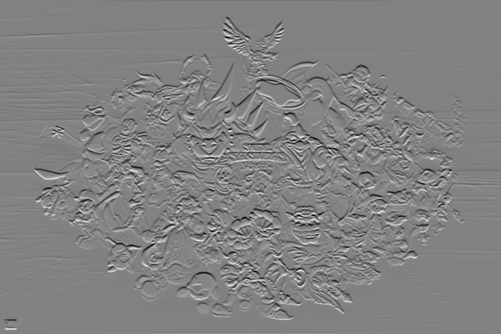

X then Y direction:



Comments:

The x-direction filter picks up edges that are in that direction. You can see that the y-direction edges are a little blurry. The same is true for the y-direction filter. The X-Y direction applies the x-direction filter first and then the y-direction on top of that. The x-direction filter only captures the x-direction edges and misses the y-direction. This will affect the y-direction filter since some of the edges in the y-direction were not picked up. Thus, the resulting image loses a lot of information.